|  |
| --- |
| *MTRX3700 Major Project* |
| **USER’S MANUAL** |
| *Jousting Robot: Charlemagne de la robotic* |

****

|  |
| --- |
| **House of Faintree**  10/28/2015 |

**Revision Sheet**

|  |  |  |
| --- | --- | --- |
| **Release No.** | **Date** | **Revision Description** |
| Rev. 0 | 27/10/2015 | Create User’s Manual |
| Rev. 1.0 | 28/10/2015 | Additional content |
| Rev. 2.0 | 28/10/2015 | Format revision |
|  |  |  |
|  |  |  |
|  |  |  |

**USER'S MANUAL**

**TABLE OF CONTENTS**

Page #

1.0 GENERAL INFORMATION 6

1.1 System Overview 6

1.1.1 Major functions performed by the system 6

1.1.2 The architecture of the system in non-technical terms 6

1.1.3 User access mode 6

1.1.4 System name: 6

1.1.5 System category: 6

1.1.6 Operational status: 6

1.1.7 System environment or special conditions 6

1.2 Project References 7

1.3 Authorized Use Permission 7

1.4 Points of Contact 7

1.4.1 Contact Information 7

1.5 Organization of the Manual 7

1.6 Acronyms and Abbreviations 7

2.0 SYSTEM SUMMARY 9

2.1 System Configuration 9

2.1.1 Jousting Knight 9

2.1.2 Robot Commander 10

2.2 User Access Levels 10

3.0 Quick Start Guide 12

4.0 GETTING STARTED.................................................................... 13

4.0 GETTING STARTED 14

4.1 Setup 14

4.1.1 Power: 14

4.1.2 Connection to computer: 14

4.2 User Manual Menu 14

4.2.1 Welcome Message 14

4.2.1 Set Maximum Speed 14

4.3 User Assist Menu 14

4.4 Full Auto Menu 14

4.5 Factory Mode Menu 15

4.5.1 Max Speed 15

4.5.2 PID Gain 15

4.5.3 Time Horizon 15

4.5.4 IR sample per estimate 15

4.5.5 IR sample rate 15

4.5.6 Show Raw Data 15

4.5.7 Average Data 15

4.6 Motor On/Off Menu 16

4.6.1 Motor On 16

4.6.2 Motor Running 16

4.6.3 Motor Off 16

5.0 Using the System 18

5.1 Safety requirement 18

5.2 User Operation 18

5.3 User Manual Menu 19

5.3.1 Motor On/Off 19

5.3.2 Max Speed 19

5.3.3 Mode switch 19

5.4 User Assist Menu 19

5.4.1 Motor On/Off 19

5.4.2 Mode switch 19

5.5 Full Auto Menu 20

5.5.1 Motor On/Off 20

5.5.2 Mode switch 20

5.6 Factory Mode Menu 20

5.6.1 Max Speed 20

5.6.2 PID Gain 20

5.6.3 Time Horizon 20

5.6.4 IR sample per estimate 20

5.6.5 IR sample rate 20

5.6.6 Show Raw Data 20

5.6.7 Average Data 20

5.6.8 Motor On/Off 20

5.6.9 Mode switch 20

5.7 Special Instructions for Error Correction 21

5.7.1 No Display on LCD after Switching on the System 21

5.7.2 Jousting Robot is not moving in an appropriate way 21

5.7.3 Buttons/Joystick do not work 21

**1.0 GENERAL INFORMATION...................................................................**

# GENERAL INFORMATION

## 1.1 System Overview

### 1.1.1 Major functions performed by the system

Jousting Robot, the Robot is either controlled by the Robot commander or controlled by itself to walk around the tilt and jousting with other robot

### 1.1.2 The architecture of the system in non-technical terms

Controlled Unit: Robot: Motor

Communication Unit: XBee RF Communication Unit

Control Unit: Robot Commander: Joystick, LCD, Button

### 1.1.3 User access mode

Robot commander

### 1.1.4 System name:

“Charlemagne de la robotic”

### 1.1.5 System category:

* *Major application:*

Assignment submission; Recreation; Remote controlled robot

* *General support system:*

Feedback gives back from IR sensor, Object status

### 1.1.6 Operational status:

* *Operational*

User Manual mode: The robot is controlled manually by the robot commander, it can set maximum speed and go to other mode, operations under buttons and LCD.

User Assist mode: The robot is controlled manually by the robot commander, where will be some addition command implemented by robot itself to assist user control the robot.

Full Auto: the robot will run on itself by the pre-programmed codes

Factory mode: Calibrations of the system, set maximum speed, set IR sensor sample rate, show raw statistics.

### 1.1.7 System environment or special conditions

operation need to be done indoor, under room temperature and horizontal ground.

## 1.2 Project References

User Manual (2014), *U.S. Department of Housing and Urban Development,*

[Access date: 28/10/2015] http://portal.hud.gov/hudportal/documents/huddoc?id=doc\_15160.doc

## 1.3 Authorized Use Permission

Jousting Robot hereby grants to you, and acknowledge that you are acquiring, only a limited, non-exclusive license to use the software for use only.

You agree not to make or permit the making of copies of the software except as authorized in writing by Jousting Robot.

You agree not to engage in, participate in, or knowingly permit any other reproduction, distribution, access to, or use of any of the software, nor the creation of derivatives works based on any of the software except as expressly permitted by this agreement or with the prior written authorization of Jousting Robot.

You agree to comply with all applicable laws regarding use of the software.

## 1.4 Points of Contact

### 1.4.1 Contact Information

|  |  |  |
| --- | --- | --- |
| **Name** | **Role** | **Contact information** |
| Leo | Jousting Robot representative | Leo.rep@joustingrobot.com |
| Ayush | Project manager | Ayush.mag@joustingrobot.com |
| Lydia | Hardware Engineer | Lydia.eng@joustingrobot.com |
| Ziji | Hardware Engineer | Ziji.eng@joustingrobot.com |
| Victor | Software Engineer | Victor.eng@joustingrobot.com |
| Bevan | Software Engineer | Bevan.eng@joustingrobot.com |

## 1.5 Organization of the Manual

Section 1.General information about the Jousting Robot

Section 2.General summary of the system

Section 3.Getting started, Robot setup, function introduction

Section 4.Using the system, allow user become familiar with the system

## 1.6 Acronyms and Abbreviations

IR sensor for Inferred sensor.

**2.0 SYSTEM SUMMARY............................................................................**

# SYSTEM SUMMARY

## 2.1 System Configuration

### 2.1.1 Jousting Knight

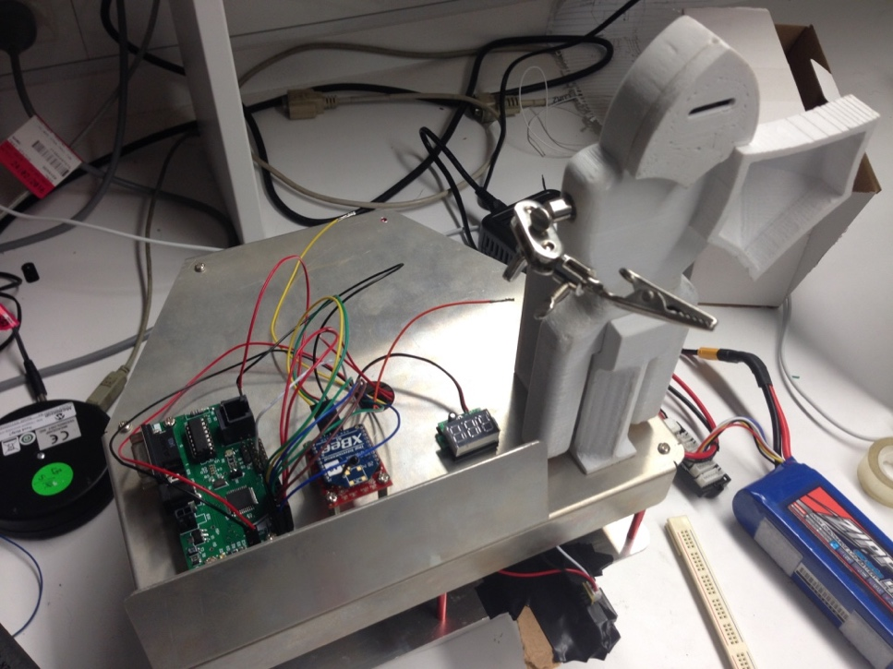

Knight

Clamp to Attach lance

Battery Voltage Display

XBee RF Communication unit

Microcontroller Board

IR Sensor

### ../../thumb_IMG_4919_1024.jpgRobot Commander

Emergency Switch

XBee Communication Unit

Motor On/Off Button

LCD Display

Joystick

## 2.2 User Access Levels

User Manual: Operating with external power, controlled by Robot Commander (buttons, dial, LCD).

User Assist: Operating with external power, controlled by Both Robot Commander (buttons, dial, LCD) and robot itself.

Auto: Robot fully controlled by itself, user can only run or stop it

Factory: Accessible for technical support and internal variable changing

1. **Quick Start Guide................................................................................**

# 3.0 Quick Start Guide

* + 1. Check the battery of both Commander and Robot, ensure battery is inserted, power on.
    2. Choose settings using joystick on Robot commander
    3. Set the mode which robot will work in and adjusting the value
    4. Use motor on button to start the motor and run the robot

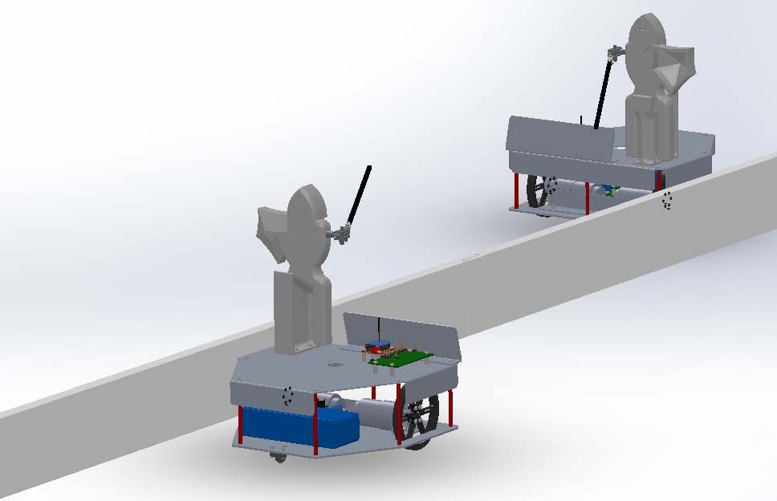

Figure 1 The Demostration of Robot Jousting

# GETTING STARTED....................................................................

# GETTING STARTED

*The Jousting Robot is powered on using an external battery, 12V lithium iron phosphate (LiFePO4) is using to provide all the power needed for motor control and control unit. When powered up, the user is faced with a menu on the LCD and will navigate through the menu to work the jousting robot.*

## 4.1 Setup

### 4.1.1 Power:

The system is using a 9V battery; this power supply will provide power for all modules and all modes that system operating in.

### 4.1.2 Connection to computer:

The Robot and the commander don't usually need connection to the computer unless it is under operation suggested by technician for developing issue or debugging

## 4.2 User Manual Menu

### 4.2.1 Welcome Message

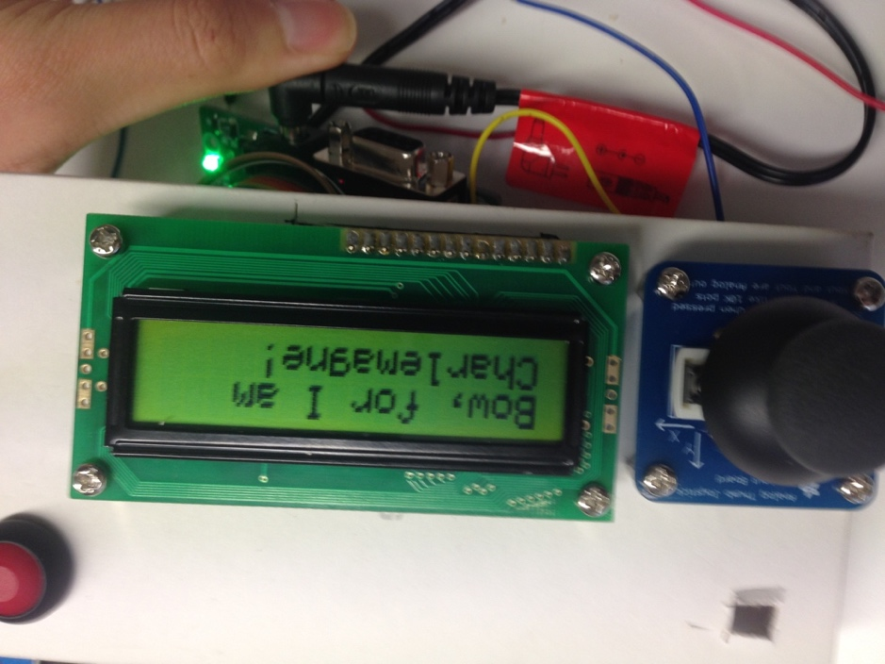

### 4.2.1 Set Maximum Speed

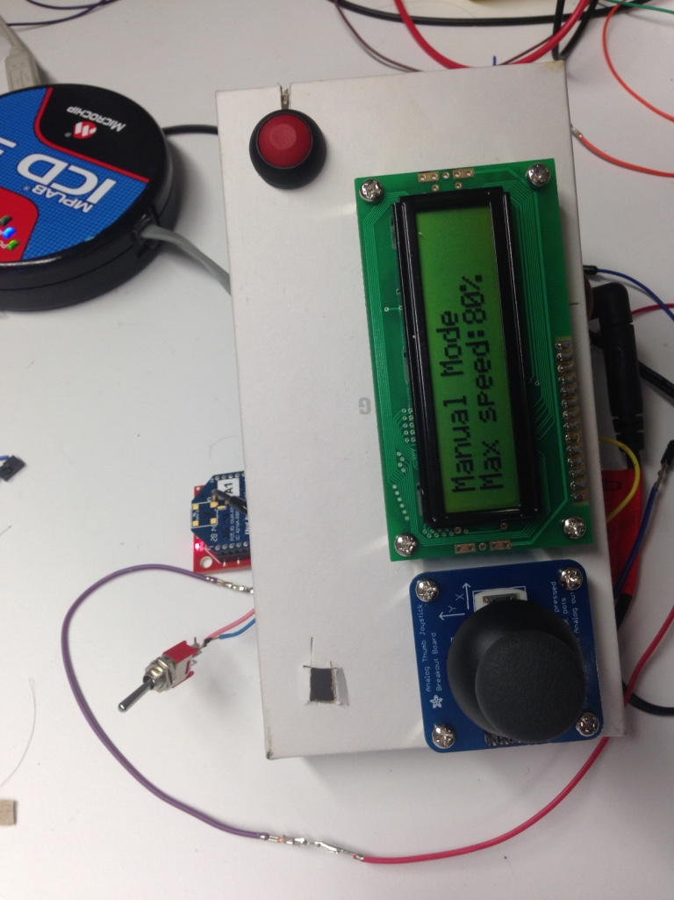

## 4.3 User Assist Menu

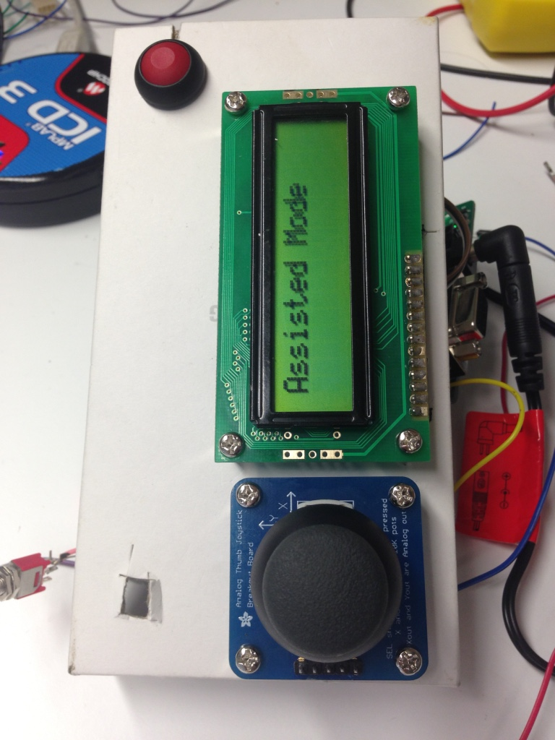

## 4.4 Full Auto Menu

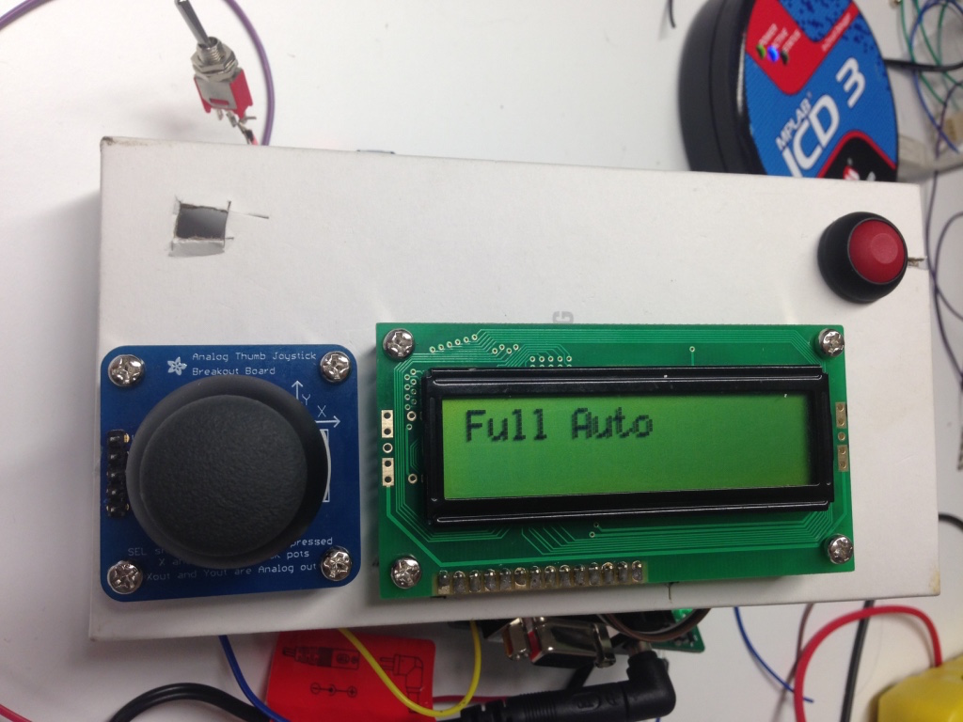

## 4.5 Factory Mode Menu

Factory Mode is for technicians or programmers wishing to further implement Jousting Robot. If there are any issue regarding using factory mode, please contact technical support.

### 4.5.1 Max Speed

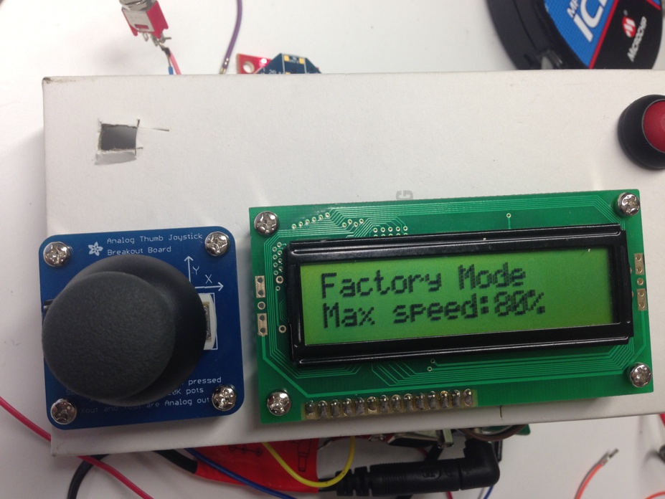

### 4.5.2 PID Gain

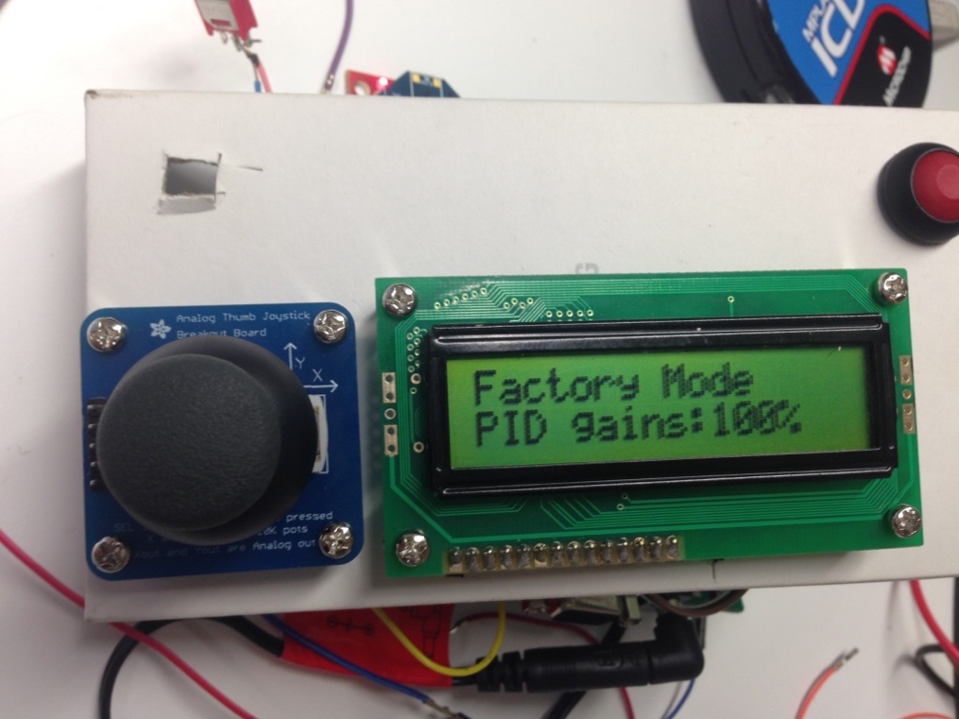

### 4.5.3 Time Horizon

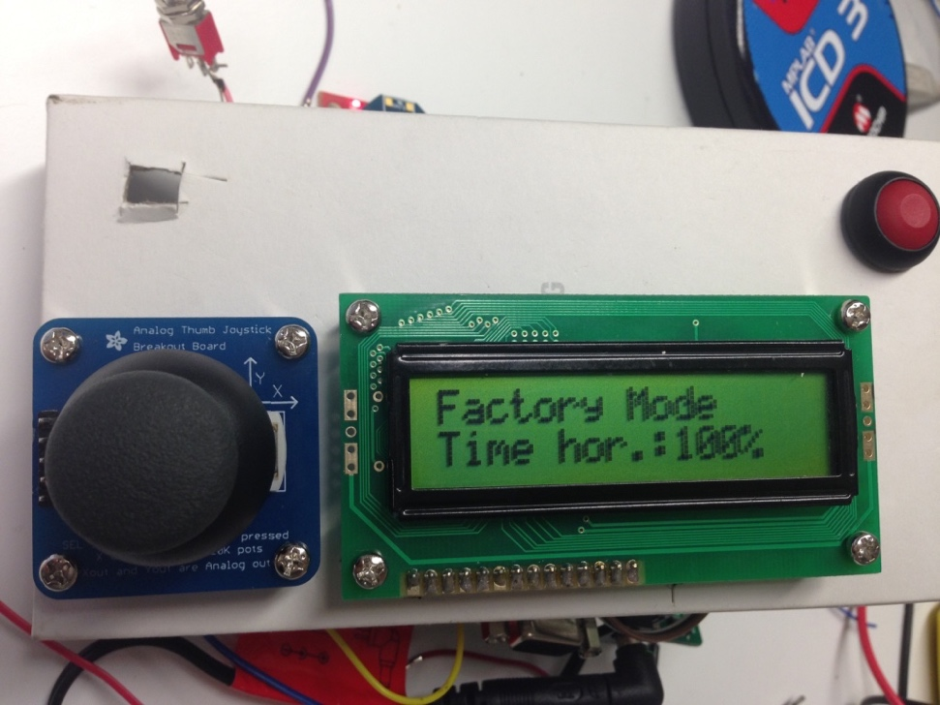

### 4.5.4 IR sample per estimate

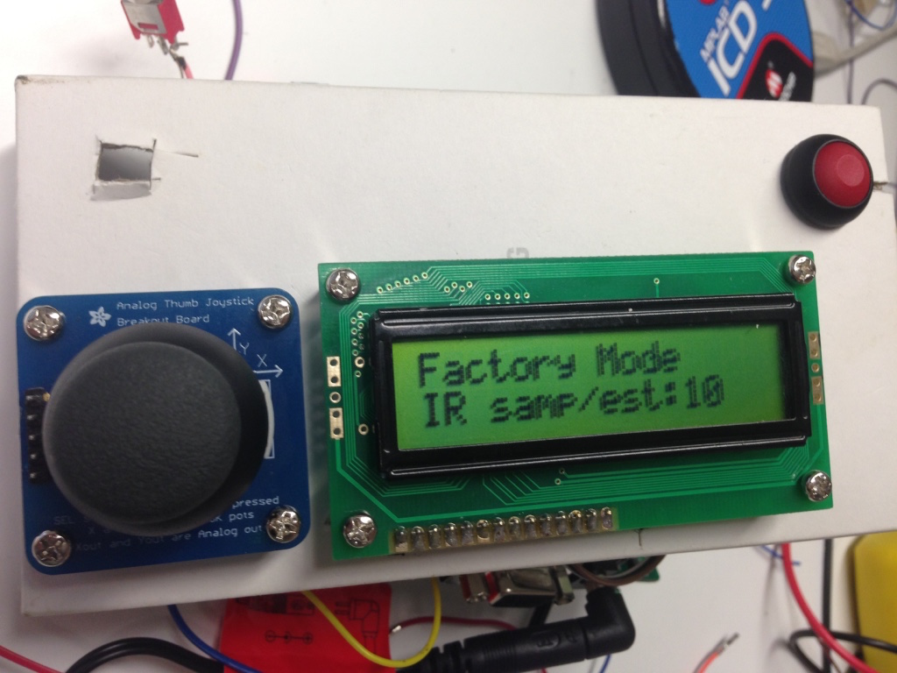

### 4.5.5 IR sample rate

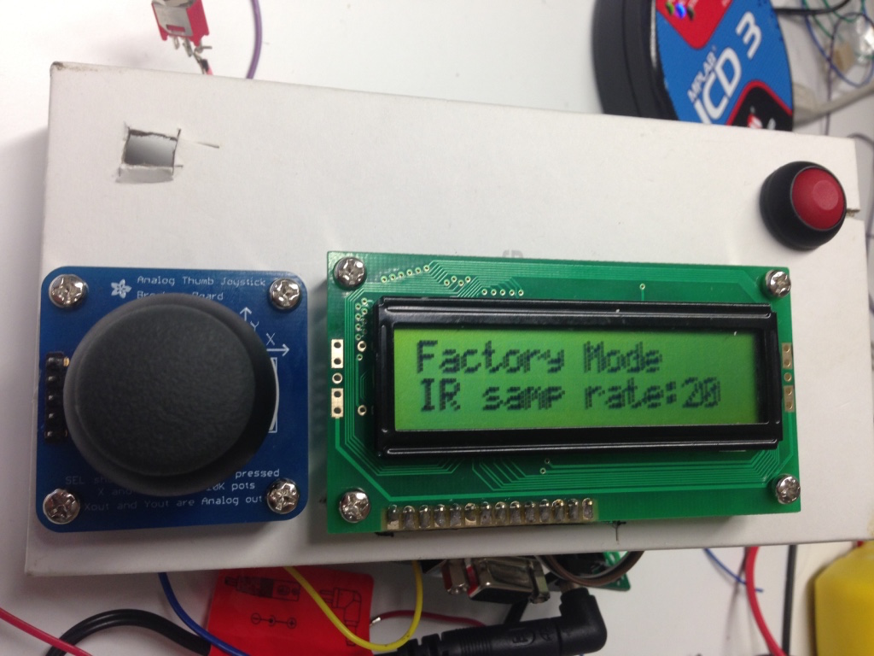

### 4.5.6 Show Raw Data

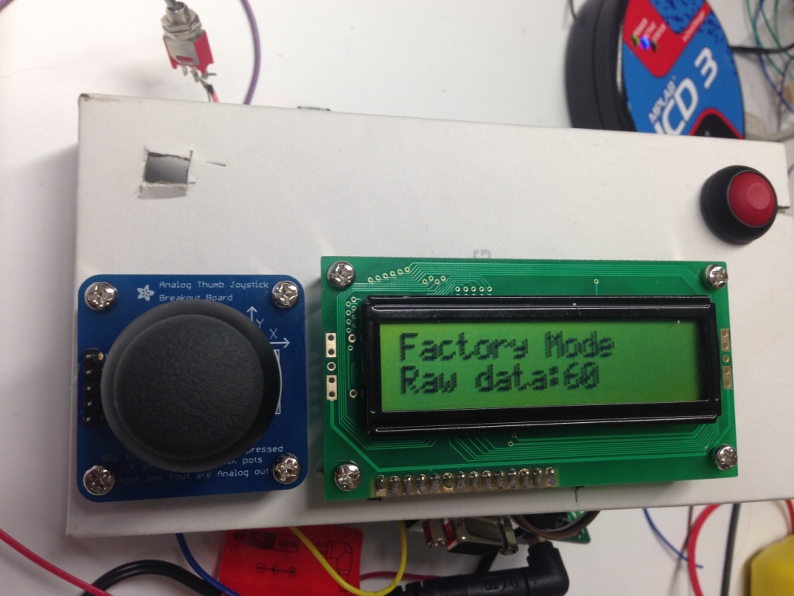

### 4.5.7 Average Data

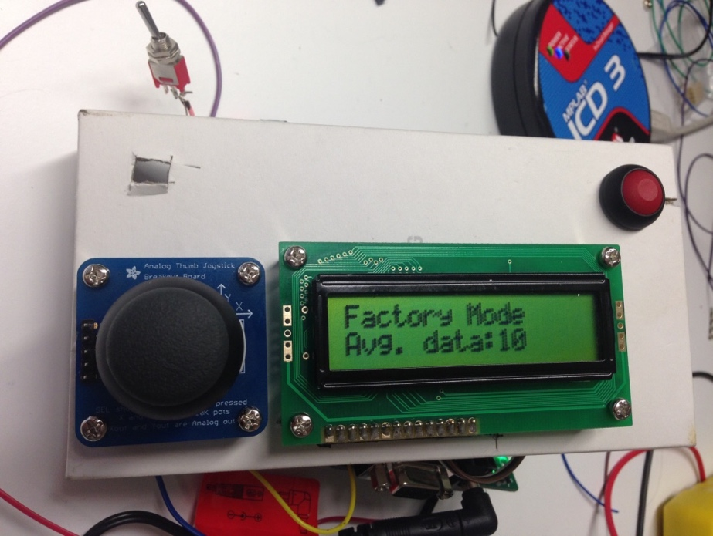

## 4.6 Motor On/Off Menu

### 4.6.1 Motor On

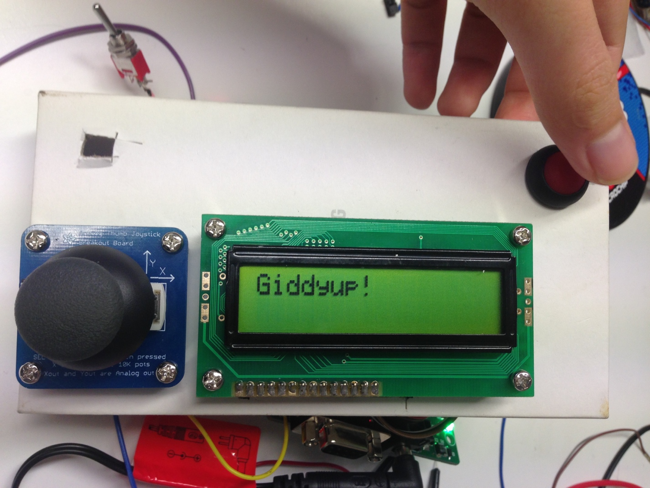

### 4.6.2 Motor Running

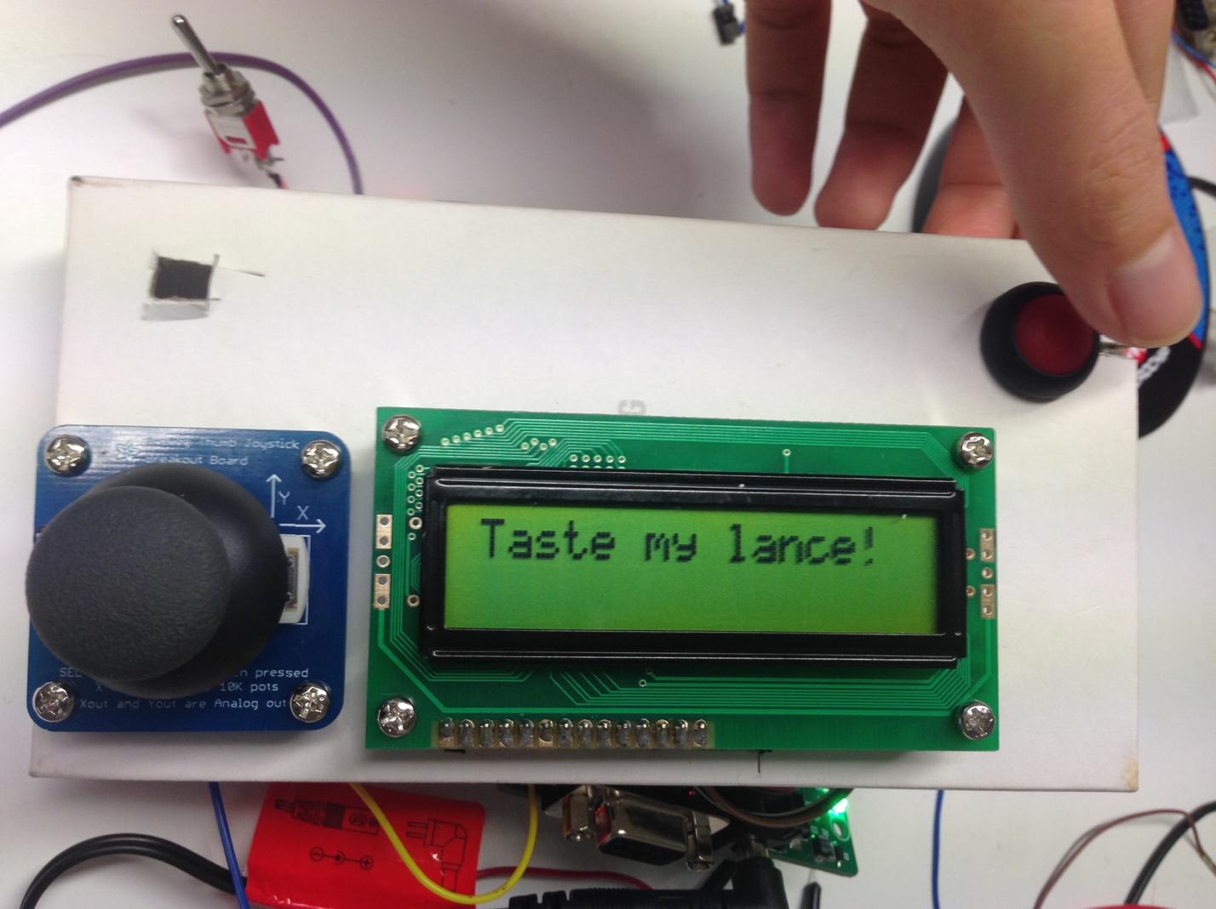

### 4.6.3 Motor Off

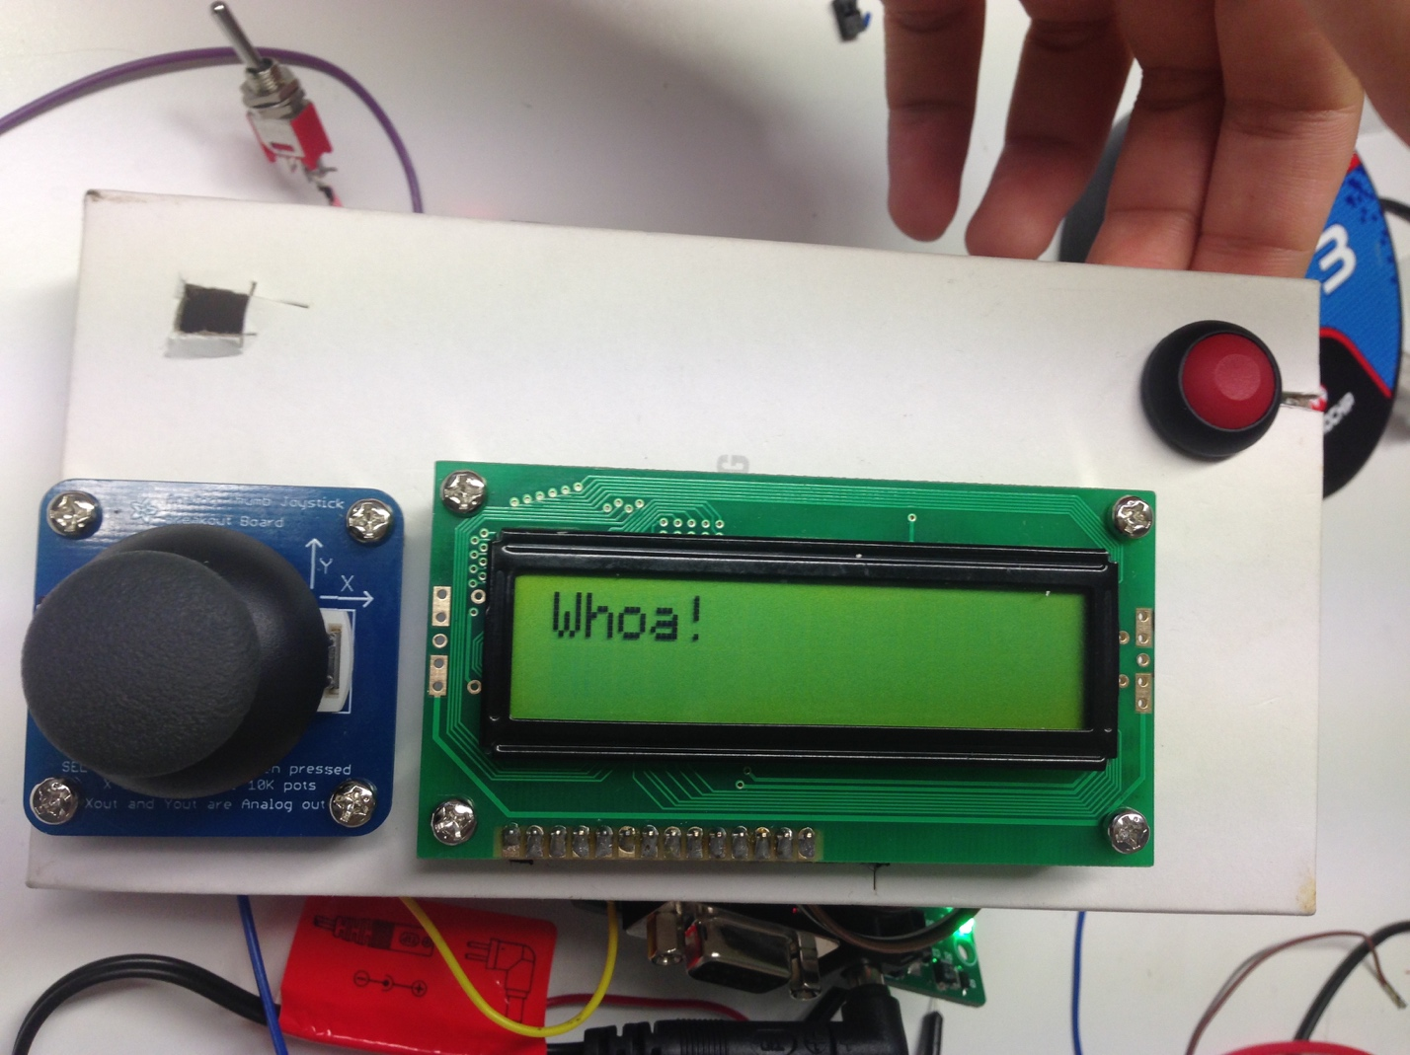

**5.0 USING THE SYSTEM......................................................................**

# Using the System

## 5.1 Safety requirement

To reduce the risk of fire, electric shock or injury:

1. The Jousting Robot is not intended for use by young children or inform persons with reduced physical, sensory or reasoning capabilities.
2. Young children should be supervised to ensure that they do not play with the fan.
3. Do not operate Jousting Robot with a damaged wire or plug. If the wire or plug is damaged, do not use Jousting Robot and contact technicians stated above.
4. If Jousting Robot is not working as it should or has been damaged, do not use and contact technicians.
5. Do not handle battery or Jousting Robot with wet hands.
6. Keep away from heated surfaces.
7. Use only as described in this manual. Do not carry out any maintenance other than that shown in this manual, or advised by Jousting Robot technicians.

## 5.2 User Operation

## ../../Screen%20Shot%202015-10-28%20at%2008.55.01.png

Figure 2 Design Diagram of Robot Commander

* When power switch is turned on, by default, commander turns on in MENU mode. Commander (and Robot) run in two main modes, MENU and RUN. These modes are accessed by pressing Button 2 which toggles between them subject to safe delays.
  + The type of RUN mode (Manual, Assisted, Auto) depends on the mode selected in MENU
* In MENU mode:
  + Robot cannot be moved
  + RUN mode (or type) can be selected (Manual, Assisted, Auto) and FACTORY MODE can be accessed. This is done by pressing Button 1 which toggles through these modes, changing also the first line of the LCD.
  + Using the Y-axis of the joystick (Only in FACTORY MODE) user cycles through the variable they want to change (e.g. Max Speed, IR Sample Rate, etc.). Using the X- axis, user changes value in increments; left for decrease, right for increase. These changes are displayed on the second line of the LCD.
* In RUN mode:
  + Settings cannot be altered
  + When initiated a starting delay and notification on LCD is initiated. Motors will turn on straight after.
    - Robot will not move in MANUAL mode until user input is given
    - Robot will move after this delay in AUTO
  + When Button 2 is pressed again, all motor actions stop and a safety delay and LCD notification is initiated to prevent accidental restarts.
* Emergency stops:
  + Implicitly the design works so that Button 2 acts as an urgent response stop measure, however further safety is added through the power switch which will halt all operation in both robot and commander upon being switched off.

## 5.3 User Manual Menu

The User Manual Mode consists of the following functions that allow the users to modify. This is found using the buttons and LCD on the Robot Commander.

### 5.3.1 Motor On/Off

Turn to the motor control mode, user can only control motor in this mode

### 5.3.2 Max Speed

User will be able to set the maximum speed, in percentage

### 5.3.3 Mode switch

Move to next Menu

## 5.4 User Assist Menu

The User Assist Mode would allow user to control the Robot through the Commander but only for controlling Motor on/off and go forward or backward, the turning of the robot will be controlled by Robot itself

### 5.4.1 Motor On/Off

Turn to the motor control mode, user can only control motor in this mode

### 5.4.2 Mode switch

Move to next Menu

## 5.5 Full Auto Menu

The user will only be able to control control the Motor on/off, all the motion will be controlled by Robot itself

### 5.5.1 Motor On/Off

Turn to the motor control mode, user can only control motor in this mode

### 5.5.2 Mode switch

Move to next Menu

## 5.6 Factory Mode Menu

Factory mode is created for advanced users of death star tracking system. People without the knowledge of the death star tracker should not be entering this mode. This mode has several additional commands that can be executed including calibration and sample rate settings.

### 5.6.1 Max Speed

User will be able to set the maximum speed, in percentage

### 5.6.2 PID Gain

*-Under construction*

User will be able to set the PID Gain

### 5.6.3 Time Horizon

*-Under construction*

User will be able to set the time horizon value, in percentage

### 5.6.4 IR sample per estimate

Will set number to IR measurements used to estimate the range between robot and the tilt.

### 5.6.5 IR sample rate

Set the rate of IR measurements used to estimate the range between robot and the tilt.

### 5.6.6 Show Raw Data

The raw reading from IR sensor will be displayed on LCD

### 5.6.7 Average Data

The average from IR sensor will be displayed on LCD

### 5.6.8 Motor On/Off

Turn to the motor control mode, user can only control motor in this mode

### 5.6.9 Mode switch

Move to next Menu

## 5.7 Special Instructions for Error Correction

### 5.7.1 No Display on LCD after Switching on the System

Possible causes➀: The battery is running low

Solution: Change a new battery

Possible causes➁: Internal connection issue

Solution: Contact technician for more support

### 5.7.2 Jousting Robot is not moving in an appropriate way

Possible cause➀: Motor might have some problem

Solution: Contact technician for more support and information

Possible cause➁: Wheels might have some problem

Solution: Contact technician for more support and information

### 5.7.3 Buttons/Joystick do not work

Possible cause: Internal connection issue

Solution: Contact technician for more support and information



MTRX3700 Mechatronics 3

University of Sydney

For more information about Jousting Robot, please refer to House of Faintree

The product is only provided in MTRX3700 Mechatronics 3, University of Sydney

Copy Right ©House of Faintree 2015